**DAY ONE – WET LAB EXERCISES**

**NS&B – STG Integrative Molecular Module**

**EXERCISE ONE – PIPETTING EXERCISE AND USING THE NANODROP:**

**Learning objectives**

* Develop accurate and repeatable pipetting skills
* Prepare a serial dilution of nucleic acids with precision and accuracy
* Analyze and interpret a spectral data from a NanoDrop

**Rationale**

The entirety of the molecular biology workflow consists of accurate and repeatable pipetting skills. Without the ability to pipette carefully and consistently, your data will be unusable. To foster and monitor pipetting skills, as well as to get you thinking of dilutions and working concentrations, we will begin with a simple pipetting exercise. This exercise will also introduce you to the use of the Nanodrop for quantifying nucleic acids via spectrophotometry.

**Serial Dilution Series**

A serial dilution is the stepwise dilution of a substance in solution. Usually the dilution factor at each step is constant, resulting in descending concentration in logarithmic fashion. Serial dilutions are used to accurately create highly diluted solutions or to create standard curves with a logarithmic scale. Ten-fold and two-fold serial dilutions are commonly used in molecular biology.

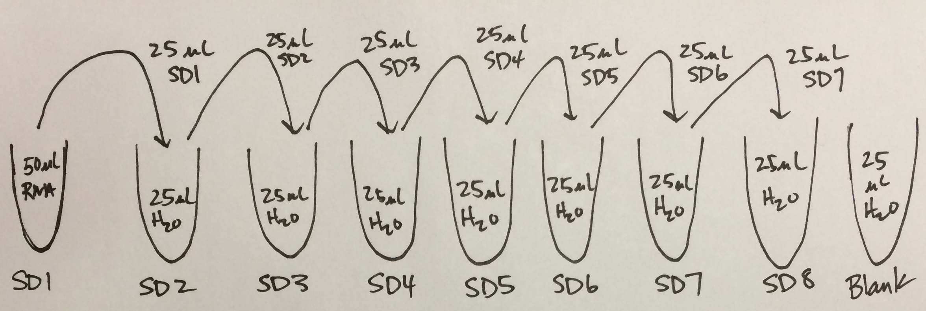A **two-fold serial dilution** reduces the concentration by one half. For instance, the final concentration of the series could be: 200 M, 100 M, 50 M, 25 M, 12.5 M, 6.25 M. Here is an example of how one might create a two-fold dilution series.

A **ten-fold serial dilution** reduced the concentration by a factor of 10. For instance, the final concentration of the series could be: 100 M, 10 M, 1 M, 0.1 M, 0.01 M, and 0.001 M.

**SPECIAL CONSIDERATION:** This is your first chance to think about the unwritten considerations of molecular biology work. This is a computation done ahead of time that is rote for molecular biologists. It includes thinking about *gloves, ice, racks* and *tubes.* You need to visualize the experiment so you can organize your thoughts about how you will progress through the experiment and what level of sample protection is necessary. This you should do before picking up any pipetters. Set up your thoughts, and then set up your tubes and racks!

EXERCISE ONE – WORKFLOW for the PIPETTING EXERCISE:

**Before beginning – read through and think about your workflow. Gloves, ice, racks and tubes. What will you need and why?**

1. Obtain an aliquot of RNA for use in the exercise. What is the initial listed concentration of the RNA? Record this number in your notebook.
2. Before diluting your RNA, spec the RNA out on the Nanodrop machine Record the concentration and the OD260/280 in your lab notebook. If possible, save the output of the Nanodrop and import it into your Powerpoint notebook file. What is this output, and what information does it give you about the RNA? What information is *missing* from this RNA measurement? How does the measured concentration compare with the reported concentration of the RNA standard?
3. Using the starting concentration you just measured on the Nanodrop, we will create a **serial dilution series** that will test your pipetting skills and determine the detection limits of the Nanodrop machine. Design a dilution series that will cover at least 5 concentrations of RNA and will result in a final concentration of your RNA that is < 0.5 ng/µl. Check with one of the instructors before beginning your dilution series to make sure it is well designed.
4. Quantify the concentration of RNA in each of the samples in your dilution series using the Nanodrop. Make note of any differences or changes in the OD260/280 or the spectrum across your samples. Record in your notebook.
5. Plot the results of your dilution series with the dilution factor (or predicted concentration) on the X-axis and the measured RNA concentration on the Y-axis. Fit a line to the data. Include this figure in your Powerpoint notebook.
6. Interpret the results. What do the slope and y-intercept of this line represent?
7. Share your results with one of the instructors, and make sure you are “cleared” to move forward. We may ask you to re-do some of the curve if we feel your pipetting could benefit from a little more practice.

EXERCISE TWO – ONE-STEP qRT-PCR TO LOOK AT QUALITY OF RNA:

**Learning objectives**

* Understand the difference between quantity and quality of RNA samples
* Gain experience assembling a qPCR reaction
* Learn to manage your workspace for molecular work
* Continue to develop accurate and repeatable pipetting skills
* Prepare a serial dilution of nucleic acids with precision and accuracy

**Rationale**

Spectrophotometry can provide a useful quantification tool for nucleic acids, and give you some insight as to whether your sample has contamination from the RNA extraction process. However, spectrophotometry can assess nothing about RNA quality. We will introduce you to a quality-control step we use for our samples that is based on real-time PCR quantitation of high abundance RNAs present in all samples.

**RT-PCR**

PCR is ultimately based on amplification of DNA, as the enzymes involved are much more efficient in replicating a DNA template than an RNA template. Therefore, all biological samples (RNA) must be converted to DNA to be used in PCR. This process is called **reverse transcription** and this is the “RT” in “RT-PCR.” Note: RT does not stand for “real-time.” You will learn much more about the process and biology of reverse transcription in a later exercise.

**rRNA**

The most abundant RNA species in biological samples are ribosomal RNAs (rRNAs). Many techniques that assess the quality of RNA do so via looking at the integrity of ribosomal RNAs in the sample. There are many ways to do this, the most common being gel electrophoresis to visualize rRNA bands. A more up to date way of doing this is through a BioAnalyzer type machine, which uses capillary electrophoresis to separate RNA and then absorbance measures to quantify ribosomal content. Because our endpoint is qPCR, we have developed a simple and straightforward way of validating RNA quality using a qPCR based approach.

**One-Step Reactions**

What is a “one-step” reaction? Normally, the enzymatic reactions involved in reverse transcription and PCR and carried out separately in sequence. In a one-step reaction, these different enzyme mixtures are combined to serially conduct RT and PCR all in one tube.

EXERCISE TWO – WORKFLOW for ONE-STEP qRT-PCR:

**Before beginning – read through and think about your workflow. Gloves, ice, racks and tubes. What will you need and why?**

1. You will find a protocol in your shared folder called “**BioRad-OneStep-qRTPCR.pdf**”. Open this protocol and read it through before starting the exercise. Even if you don’t understand everything in the protocol, a once-through will prime you for what is to come.
2. Obtain an aliquot of RNA for use in the exercise. We will be using total RNA extracted from crab (*C. borealis*) brain.
3. Before diluting your RNA, spec the RNA out on the Nanodrop machine Record the concentration and the OD260/280 in your lab notebook. If possible, save the output of the Nanodrop and import it into your Powerpoint notebook file.
4. Design a dilution series that will consist of 4 samples. The first concentration should be 50 ng/ul and each step in the dilution series represents an 8-fold dilution. Check with one of the instructors before beginning your dilution series to make sure it is well designed. These diluted samples will each be used as an individual sample in a qRT-PCR reaction to quantify 18S rRNA levels in the sample.
5. Obtain a pair of 18S rRNA PCR primers from an instructor. Note the concentration of the primers you are given.
6. Consult the BioRad protocol file and construct a blueprint of a qRT-PCR reaction with the following parameters:
   1. Each concentration will be measured in triplicate in 10 μl reactions.
   2. Forward and reverse primers will be at a final concentration of 300 nM each.
   3. Each reaction of a triplicate will get 2 μl of input RNA.
7. When your experimental design and reaction mix plan is complete, run it by one of the instructors and make sure all is well before proceeding with the reaction construction. When given the green light, make sure to record all pertinent information in your lab notebook.
8. Set up your reactions.
9. Each reaction is loaded into its own well in a 96-well plate. All of you will share one plate, so when you are ready to load the plate **let us know and we will set up a queue for loading the plate.**
10. When everyone has loaded the plate, we will take you up and load the plate on the realtime machine and provide further instruction at that point.
11. While the plate is running, think about what your expectations are for the outcome. Also, revisit the process of setting up the reaction. What went wrong that slowed you down? What could you have done better?
12. We will look at and analyze the data together.